GUIDANCE FOR ABSTRACT PREPARATION
Author A.B., Author C.D.⁽¹⁾, Author E.F.⁽²⁾
Full organization name, post address, e-mail
⁽¹⁾Full organization name, post address, e-mail
⁽²⁾Full organization name, post address, e-mail

Abstracts should be prepared in English and not exceed one page in length (A4 format, 29.7 сm × 21 сm), including tables and figures, by making use of Microsoft Word 6.0-7.0 versions.  The abstract title should be typed by capital letters of Times New Roman bold font, 14 point, and centred in the first line over the width of two columns. Next line is blank. Next, the names and initials of authors should be typed with 12-point bold font, and centred. The name of presenting author should be underlined.  Next, the full name, post address, and |  | e-mail of organization (for each – in separate line) should be typed with 12-point font and centred. Next line is blank.  The two-column text of abstract should be typed with 11-point font using single line spacing. Margins: 3 cm top, 2 cm down, left, and right. Spacing between columns is 1 cm.  High-quality illustrations should be prepared as JPG or BMP files. References should be numbered consecutively (numerals in square brackets) throughout the text and collected together in a reference list at the end of abstract.

IMPORTANT
Abstract submission deadline: June 30, 2015. The abstracts submitted after deadline or prepared wrong will not be accepted.
Additional information about authors has to be given with the following form:

AUTHOR INFORMATION

Submission title:
Topic index:
Presentation type: |  |  |  | Oral |  |  |  |  |  | Poster |  |  | Plenary
1st participant; 2nd participant, etc. First name, middle name, last name:
Organization name:
Position:
Post address (street, city, postal code, country):
Phone:
Fax:
E-mail (necessarily):

Conference Secretariat:  Chernyshev Leonid,  Fedorova Natalia  Address: Institute for Problems of Materials Science of NASU  3 Krzhyzhanovsky St., 03680 Kiev, Ukraine  Phone: +38 (044) 424-20-73  Mob.phone: +38-050-358-94-75  Fax: +38 (044) 424-21-31  E-mail: umrs2004@ukr.net | IMPORTANT DEADLINES:  - 1st announcement – 20.05.2015;  - submission abstracts – 30.06.2015;  - 2nd announcement – 01.08.2015;  - application for participation – 01.09.2015;  - fee payment – from 01.08 2015 to 25.09.2015.
National Academy of Science of Ukraine (NASU)
Ukrainian Materials Research Society
national Technological University of Ukraine “KPI”
Frantsevich Institute for Problems of Materials Science of NASU

5-th INTERNATIONAL CONFERENCE

HighMatTech
Informational partners, journals:  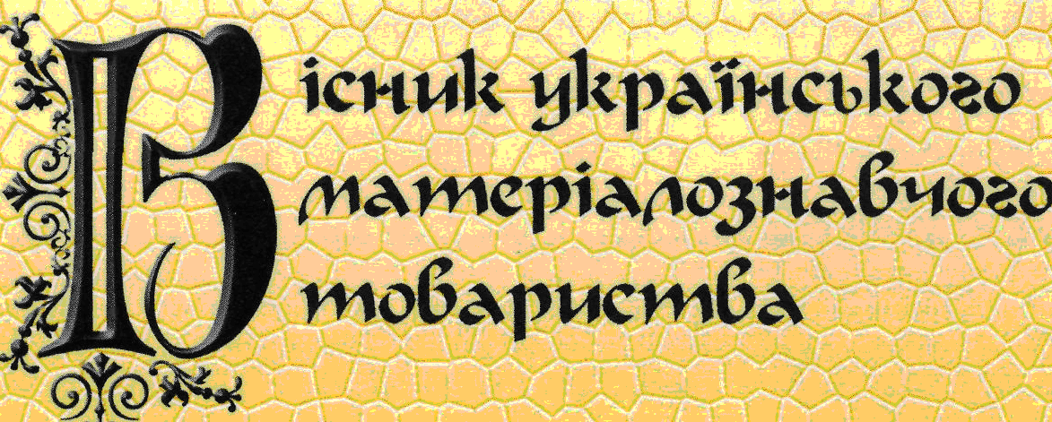  “Bulletin of U-MRS” (Ukraine) |  | Informational partners, journals:  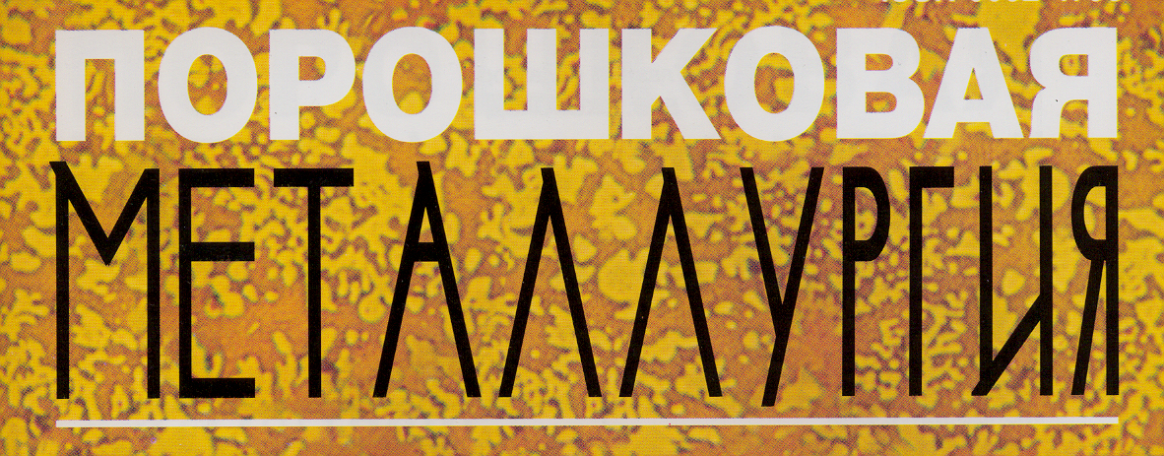  Powder Metallurgy (Ukraine)  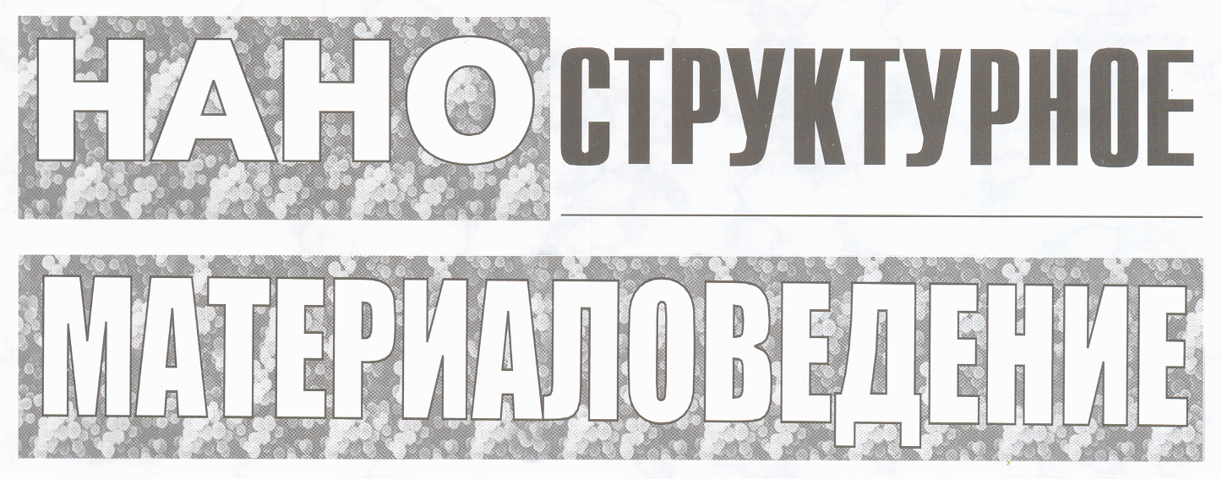  Nanostructure Materials Science (Ukraine)

First Announcement
October 5 - 8, 2015
Kiev, Ukraine
ORGANIZING COMMITTEE

Skorokhod V. – Chairman, Prof., Ukraine
Chernyshev L. – Scientific Secretary, Dr., Ukraine

MEMBERS OF COMMITTEE

Antsiferof V. – Prof., Russia  Barinov S. – Prof.,Russia  Danninger H. – Prof., Austria  Dikusar A. – Prof., Moldova  Dmitrik V. – Prof.,Ukraine  Frage N. – Prof., Israel  Ivanchev S. – Prof., Russia  Ivasishin O – Prof., Ukraine  Kostornov A. – Prof., Ukraine  Kryl Ya. – Prof., Ukraine  Kulu P. – Prof., Estonia  Levashov E. – Prof., Russia  Li Tsyanzhu – China | Lobanov L. – Prof., Ukraine  Loboda P. – Prof., Ukraine  Mileiko S.T. – Prof., Russia  Movchan B. – Prof., Ukraine  Naidek V. – Prof., Ukraine  Naidich Yu. – Prof., Ukraine  Novikov N. – Prof., Ukraine  Panin V. – Prof., Russia  Paustovskiy A.- Dr.,Ukraine  Prikhna T. – Prof., Ukraine  Ryabicheva L. – Prof., Ukraine  Rumyantsev V.– Russia  Savich V. – Dr., Byelorussia  Sanin A. – Prof., Ukraine  Shalunov E. – Prof., Russia | Shemet V. – Prof., Germany  Sidorenko S. – Prof., Ukraine  Smertenko P. – Ukraine  Szafran M. – Prof., Poland  Tamulevicius S. – Prof., Lithuania  Tavadze G. – Prof., Georgia  Varyukhin V. – Prof., Ukraine  Vishnyakov L. – Prof., Ukraine  Yurkova A. – Prof., Ukraine  Zalite I. – Dr., Latvia  Zinchenko V. – Prof., Ukraine
Conference topics
- Fundamental principles of contemporary materials science. Modeling of the technological processes for making materials and the properties of contemporary materials for various purposes.
- Metallic materials and technologies for production. High-entropy alloys.
- Powder metallurgy: science and industry; modern materials, technologies and properties.
- Nanomaterials science: technologies and materials.
- Ceramics for functional and constructional purposes. High-temperature and heat-resistant materials.
- Latest developments in the field of designing polymeric materials with improved characteristics.
- Composite materials: special properties and prospects in practical use.
- Engineering of surface.
- Modern technologies of joining of materials.
- Equipments and methods for characterization materials.
GENERAL INFORMATION
At the end of 1980s, on initiative of one of the leading Finnish scientists Prof. K. Lilius, the series of scientific conferences-exhibitions have been launched with participation of scientists and specialists from the Western and Eastern Europe. Those events were named as MatTech, and the scientists from opposite political coalitions have received the opportunity for wide contacts. The events have been held in Helsinki, Strasbourg, and St.-Petersburg, and they promoted well establishing the fruitful scientific and personal contacts. The hundreds of scientists and manufacturers from Europe and former Soviet Union have participated those events.
From Western party, the events were held under auspices of such respected in scientific society organizations as E-MRS and FEMS.
After 15-years interval one of the holder of MatTech conferences Frantsevich Institute of Problems of Materials Science of NASU on 2007 restored the organization of International conferences with wide materials research profile under new modern brand – HighMatTech. Conferences in 2007, 2009, 2011 and 2013 caused interests on materials research scientists from many countries: Ukraine, Russia, Byelorussia, Georgia, USA, Canada, France, Germany, Great Britain etc. Exchange modern scientific results may promote the participation in International research programmes of future. Special meeting on this problem is planed.

CONFERENCE REGULATIONS
Conference fee amounts 300 EURO and is aimed to renting halls, publishing conference proceedings, organization of sessions.
The official languages of conference will be Russian and English.
Abstracts of one page length have to be prepared in accordance with instructions and submitted by e-mail to umrs2004@ukr.net. You will receive the confirmation from Organizing Committee as to submitted abstracts.
The proceedings of HighMatTech-2015 will be published in a number of journals. Acceptance of papers is subject to the usual refereeing procedure.
The conference will be organized in comfort lecture halls of Kiev Polytechnical Institute. Parallel section meetings are planed.
Friendly meeting is planed on October 6.
Materials about HighMatTech-2015 will be on the web sites: www.ipms.kiev.ua, www.umrs.kiev.ua
Short Information about Kiev
We invite you to attend Kiev, one of the most beautiful cities of Europe, which has more than 1500-year history. Among the sights of our capital is world-wide known Kievo-Pecherskaya Lavra, Sofia Cathedral, central street of Kiev – Khreschatik, picturesque river Dniper with beautiful bridges, numerous churches, parks, theatres. Kiev is widely known cultural and scientific center of Ukraine. There are a number of academical and educational institutes and universities engaged in the field of materials science.
Normally the weather in that season is rather warm (+10 - +15ºC), when trees have green leaves slightly colored in autumn gold.
The hotels for accommodation of conference participants are also located close to the place of conference. Accommodation cost is 100-200 Euro depending on lodging comfort.
Kiev has a large amount of railway and air connections with many cities throughout the world. It takes one hour to reach the center of Kiev from airport Boryspol. New comfortable railroad terminal is connected with city center by metro, trolleybus, and tram. The participants from EU, USA, Canada and Japan may attend Ukraine without visa.

